**ELL880 Assignment 1**

**Anish Majumder**

**2020EE30580**

**Dataset:** https://networkrepository.com/soc-dolphins.php

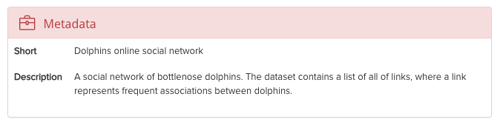

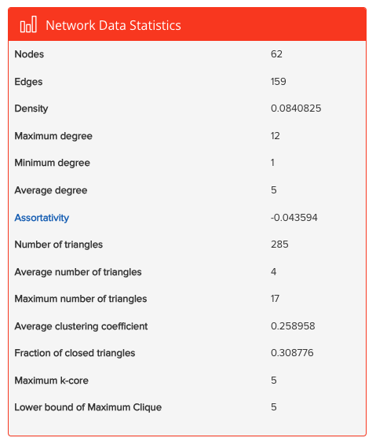

**Tools and Libraries Used:** Gephi, NetworkX, MatplotLib, Numpy

**Part A -> Tools**

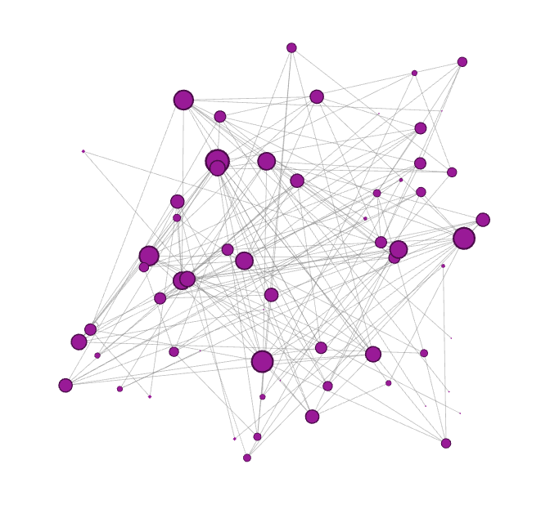**2. Visualize the graph using 2 different layouts**

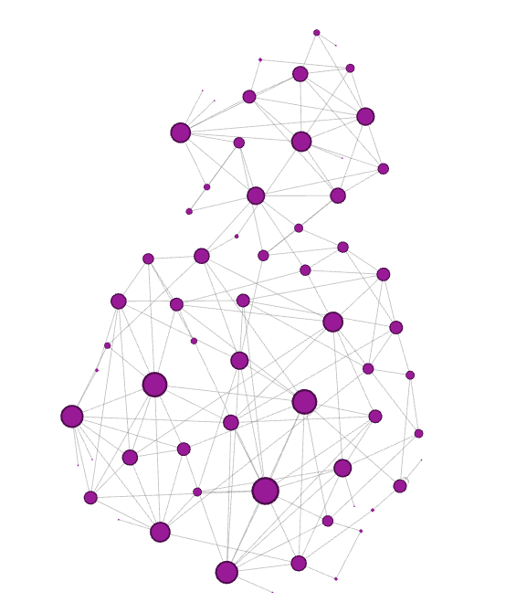

Two of few layouts available in gephi -> Yifan Hu (left) , Random Layout (right)

More Layouts in Jupyter Notebook

**3. Calculate the Degree Distribution**

Average Degree: 5.111  
  
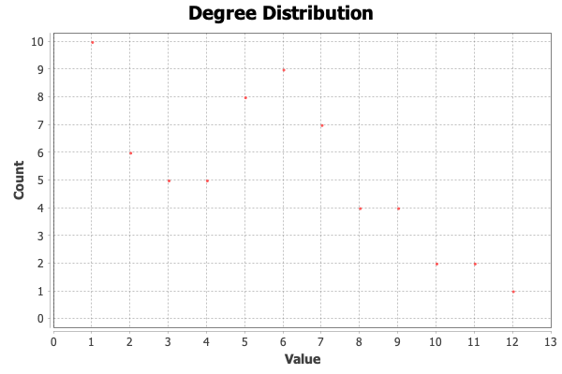

**3.i Assign sizes to vertices based on their total degree.**

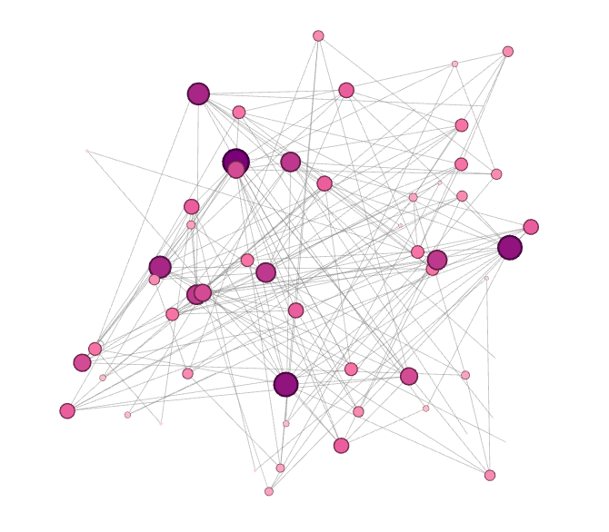

**Intensity of color of node and size of node is proportional to degree of node here**

**4. Filter the network by degree such that only the:**

**4.i Bottom 10% of nodes and the connection among them are visible.**

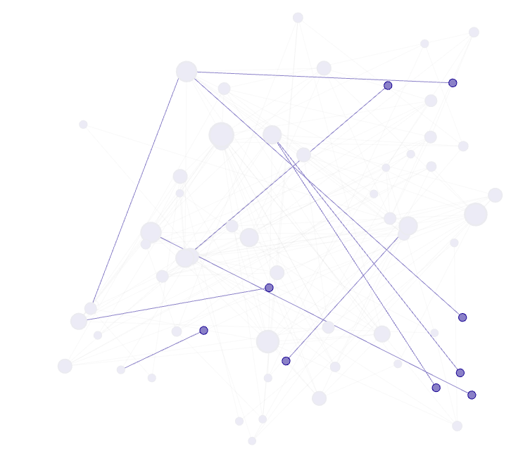

As we can see the bottom 10% nodes have degree = 1, and they have only one edge

**4.ii Top 5% of nodes and the connections among them are visible.**

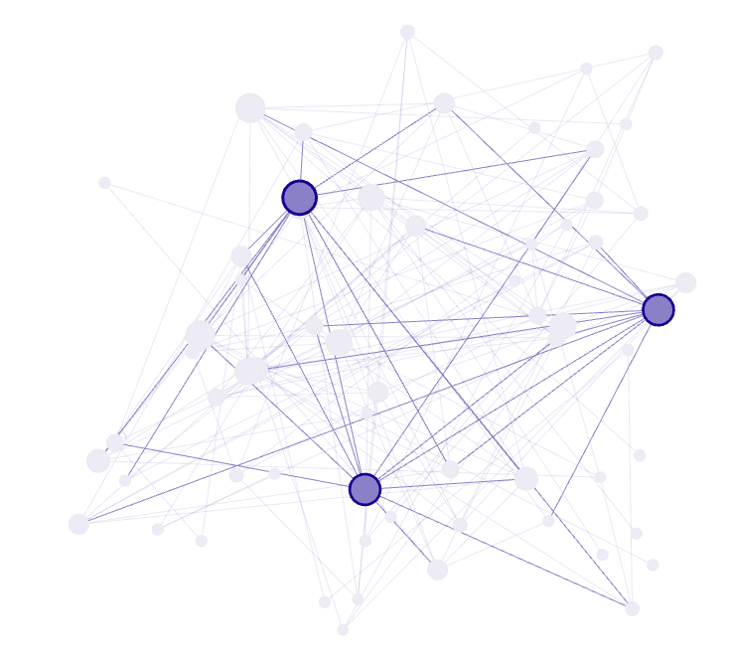

**We can see the top 5% nodes have a lot of connections**

**5. Find**

**5.i All the connected components of the network**

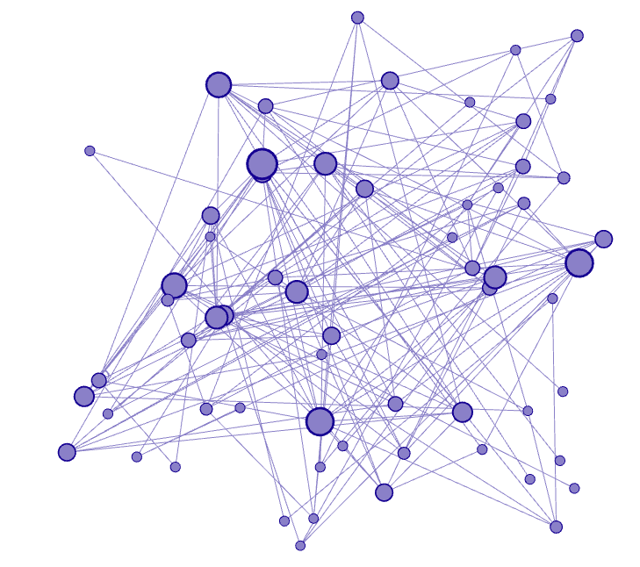

**Only one large connected component in the graph**

**5.ii The size of the giant component of the network -> 63**